AMAZON COMPANY MERGES WHOLE FOOD COMPANY
Student
Tutor
Course
Date

AMAZON COMPANY MERGES WHOLE FOOD COMPANY
It is exactly one year since Amazon company merged Whole Food Company. The time of agreement came at the time the grocer was in the pressure from the objector investor Jana Partners, whereby Whole Food Company was struggling a lot. At first it was specialty organic game but a great competitor also stimulated the space. This is where I came to recognize that the company was ceding ground. With the better scale and infrastructure, the traders could provide many of the similar goods at a better price. Whole Food Company was at the back its competitors in the technology and improvement of the loyalty program. I found that Whole Food Company challenges showed through in its funds. For example, in 2017, before merging to Amazon Company, similar stores were waning to 1.5%, as per regulatory filings. I also recognized that the previous year there were waning to 2.5%. The transaction between the two companies combined under great secrecy after the Whole Food CEO John Mackery came to Jeff Bezos My CEO in Amazon company through an industry consultant.Whole Food Company was informed by Amazon company that if the agreement is leaked, it will call it off (Ross, & Presti, 2018). A year back, Whole Food Company issued Amazon Company with the brick and mortar podium that many internet traders have started to recognize is significantly minimizing the cost of returns, marketing and delivery. As a result, the Amazon Company started selling devices such as Echo in stores and at the same time opening up lockers in definite Whole Food regions.The various stores have symbols of special discount for Amazon Company Prime members. I also realized that the Whole Food Company had started to sell goods free delivery for Amazon Prime members.

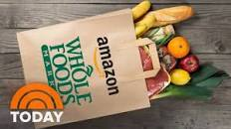
ORGANIZATIONAL BEHAVIOR
I faced many challenges when the Amazon Company was merging with Whole Food Company. The organizational behavior of the companies was totally different. For example, Amazon’s achievement of Whole Food Company last August was the business that involved mixing tap water with addition of organic virgin olive oil. I found it hard pushed to have the two companies with more unusual values prepositions. It was amazing to obtain reports abruptly after the merging of Whole Food clients, whereby the customers were really angry because of regularly coming across empty shelves at their desired retailer. These stories were faced by Whole Food Company workers crying over their new working routine caused by some working conditions obligated by Amazon Company. Amazon modified its name by being efficient, cheap, fast in utilizing data to do its goods mix and implementing strict workers discipline to compress cost of savings in order to pass on to its clients. Whole Food Company on the other hand, had frequently prided itself on its private touch on empowering its own stores together with the individual workers in order to make fast decisions on items that highlight high quality healthy home foods. The decentralization brought massive inefficiencies that increased prices to the position where detractors known to the store as Whole Paycheck. The achievement was initially obtained positively by Wall Street that accompanied the anticipation that Amazon’s data created in the mindset and could immediately be like something to help the Whole Food Company to level and increase more stores while keeping its workers empowerment culture. I came to know that is not a story where there is available bad man and a good man (Nasi,Taber & Van Vliet, 2011). This is because it is a story where the borders are weighing this high empowerment model and what limits a model standardization data. There was a model of empowerment, since the Whole Food Company decentralized form that had helped it in saving a cult following, and obtaining rapid growth from Texas and its Austin across the country. Managers could run stores like sovereign fiefdoms, help to tailor items based on client preferences for brand new in local produce. Workers are called as team workers in order to create relationship with buyers whom they cater their needs and came up with good ideas such as bike messenger service or offerings or a new bread recipe which occasionally found their way to added stores. I this modal empowerment provides a marvelous creative solution and a huge connection with local suppliers clients as well. They were pleasing to a wealthy client with a curated collection of healthy goods that people could belief. Another thing is that the company brought loyalty from group members since it was named after one of the Americans best organizations to work for Fortune Magazine which is shocking for twenty years in a row.In various methods the company became a fatality of its own success as a leading company in providing sustainable foods. Even though in 2013, Whole Food Company had a high challenge in loosing market contribution to less expensive alternatives for example, Walmart which had obtained organic space, but by the year 2017, this specific company had begun closing stores. I also faced a challenge in turning data into client value. This is because Amazon Company had contrast which was often about low efficiency prices that pursues an economical focus and meticulous performance assessment in its warehouse and distribution regions. This most of the time occurred in reports of the employee stressed out and tired of demanding environment. Amazon was facing pressures in changing the Whole Food Company slide since it could have approached the achievement differently. The type of tacit acquaintance is not easily obtained in data and working metrics. Since Amazon Company has been a specialist in delivering non-perishable products,but that dissimilar training on how to prepare particular foods, or getting how clients want their cut of meat or fish could differ in the moment. I found that Whole Food Company current cut down prices will not solve two difficulties the company creates for Amazon company. Competition and market infiltration turned the achievement of Whole Food Company into a calamity for Amazon’s bottom line. Although Whole Food Company good moments didn’t stay for a long period, the company ended up in the wrong conditions at the bad time and stores and sales openings were delayed. There was a challenge for Amazon to merge Whole Food Company because Whole Food Company does not make organic items and it distributes at its stores. It purchases the goods from farmers. Another problem is that there is market saturation. The organization has to run out of wealthy neighborhoods to sell its goods. As a result the slowed down growth of sales, intensified costing pressure that constricts profit margin. The trouble is that market infiltration and competition has continued to displease Whole Food Company even after it was merged by Amazon Company.Many people believed that if Amazon buys Whole Food Company will change the retail grocery industry, but this organization became tremendously sophisticated by being extremely competitive due to strong new competitors like Lidl which are getting the U.S. market. I realized that Amazon Company will have less than 2% of the market distribution of United States grocery traders sales. There is also a challenge in revenue dip. This is because Whole Food Company has faced high drop in similar stores as clients have gone to look for lower prices of natural goods at typical supermarkets.Amazon Company will completely sacrifice various margins by reducing prices which should assist to bring back old clients of Whole Food Company and other new customers. Online grocery buying has not been largely approved in widely area because clients want to view and touch fresh goods before they purchase. Whole Food Company will overcome this challenge by reminding clients of their high- quality freshness and helping them in delivering it. I think I face margin crunch in my company.This is because grocery goods have razor tinny margins which has often made the extra cost of home delivery a main ordering more cost successful. There will be need for customers to acquire taste of goods. High margin mortar and brick selling on a countrywide scale is very new for Amazon company. The company has confirmed it capacity to innovate and control the ever transforming hypercompetitive online selling and currently in cloud services.I found that retail grocery background nowadays is tougher, but provided it is unquenchable appetite for growth, it is not a stretch to belief the Amazon Company could do the same.

Below is the spreadsheet showing the Amazon Company successfully getting millions from FBA retailers.
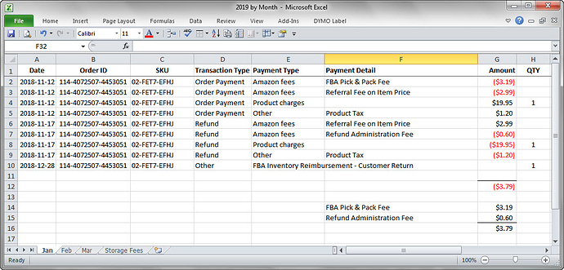
The accounting and the spread sheet Amazon trickery used to successfully steal millions of money from FBA traders. I decided to reimburse all the fees that involve FBA sellers in order to remove total amount equivalent to my sale transaction. The reimbursement value is appropriate to get a reimbursement for a repayment. Amazon Company will reimburse the FBA traders all, or some of the repayment amount of money debited from its account less the FBA fees. It is also significant to consider that Amazon Company uses the word for a refund as fight for a return. This is seriously important distinction because it actually means that my company is successfully incorporating the FBA Pick and Pack fee two times. Both the imaginative order payment for the food item encourages reimbursement of goods that were repaid by Amazon but not returned to Amazon Company. I found it is an agreeable practice for Amazon to tolerate these policies for reimbursements connected to goods destroyed or lost in the warehouse before taking to the market. I came across two major difficulties when the similar policies were functional to the transactions including goods that were only shipped by Amazon company one time to a particular client and never went back to inventory, it was physically handled by Amazon company in any method after the preliminary fulfillment. I found Amazon Customer Service recurrently repays clients whole order amounts due to the Amazon fulfillments connected issues like:
- Goods not being delivered
- But not limited to
- Goods lost after shipping to the client
- Shipments destroyed by the courier
I recognized that Amazon Company takes the reimbursement amount from the trader at the time a client begins a return for FBA order and then gives a standard repayment if the return is not obtained. Another thing is that Amazon Company never acknowledges FBA Pick and Pack fees for any motive involving the orders that are reimbursed due to state of being destroyed or lost during submission to customers. This company then incorporates the similar fees at instant time on connected repayments. I found that Amazon company can hold on money connected to orders being returned by clients, but cannot repay the funds until the return is obtained and kept into inventory. Returns that are not obtained or processed can cause hold and get reversed or lifted so that the repayment can become unnecessary.
SOLUTIONS
I found some simple solution we should all agree. For example for Amazon Company to double plunge FBA fees on repayments is completely a tortuous action. This is because the constricted services of shipping one good to one client was only carried out only once but the fees is given out two times once in the order of payment and repeatedly incorporated into FBA inventory repayment. I realized that Amazon Company’s first order of business was bringing down groceries. The company lacerated prices of items like eggs, avocadoes, fish, fruits other prepared goods by as much as 50 percent. Buyers still view bright saving every day promising around the store that contains two companies’ logos. The agreement assisted Whole Food Company steal clients away from rivals that involve Trader Joe’s and Walmart. I have to concentrate more in online shopping and delivery in order for the consumers to get new brands. For example a lot of Whole Food’s in home brands involved 365 on a daily value are currently available to buy on Amazon Company’s website. Amazon Company has to announce and commence free two hour delivery through its Prime offerings across the U.S. I think prime exclusive deal will be the best solution. This is because Amazon Company enticed in members of 99 dollars annually Prime offerings with even larger discounts. For instance, Whole Food Company is selling its roses at a low cost to Prime members during occasions like Valentine’s Day. Amazon must be faster to sell its tech items within Whole Food Company stores, since it will expand that perception with pop-up retailers across all the five Whole Food Company stores during holidays through distributing to Prime members and electronics shops (DePamphilis, 2019).The exhibits are still significant across the stores even though Amazon Company installed lockers and shelves for customers to pick up their online buying. I will put more effort to make sure this company gets a new ad complain. I think this will make Amazon Company roll out in the innovative way of ad campaign with the slogans like National TV and campaign on whatever makes consumers whole so as to emphasize on the goods of its quirky buyers. For Amazon observers, the organization’s purchase of Whole Food Company and its physical steps helps in making more money than whatever it had spent on everything of its prior acquisitions merged as a reflection of Bezos’s wider ambitions. I will make sure that Amazon Company learns how to sell food and make more dollars in internet. Grocery is the most troublesome business and that why the company has to begin layering on the prices and the challenges of delivery. I have been very keen with Amazon Company because it brought shot at stating the $800 billion in the United States in the section of grocery after the acquisition of $13.7 billion. I realized that 20% trader’s expenses go toward food and 2% of the sales come from internet marketing.
RECOMMENDATIONS
I recommend Amazon Company to look for e-commerce marketplace. This is because this company should practice monopoly in a good positioned market place especially in the Western globe. The company should expand its market distributions or shares. For example; it should trade across the world with countries like China, India, Japan and other North American and European countries. I think e-commerce business should boom by forcing strong logistics through including third party sellers. I also think it will be good idea for Amazon Company have diversified growth through its international e-commerce revenue. This will help the company’s stock to fly high in order to assess the third party trader data and duplicate the best performing goods. I will encourage my company to start limiting options and as well as assist it to stop over-promoting its goods. This will give Amazon company power to increase the prices of products. Another recommendation is this company must have its own web services in order for e-commerce business to strongly incredible. I actually argue to have AWS because it can work better. Amazon Company should start operating with the AWS before regulators begin to ant-trust its performance (Yu, Willis, Sun & Wang, 2013). The company should accomplish breakdown on the application of the Whole Food Company acquisition. Amazon Company should control food spoilage because it failed several times due to the challenge of the groceries. Whole Food Company acquisition will help Amazon company to control existing demand and greatly reduce supply risk of selling edible good to online clients. For example, cheese and ham will not be sold online because the cut prices in stores to liquidate inventory. I think all clients should interact with their amazingly convenient Amazon Company appliance so as to grab groceries online. Videos and music should be streaming in Amazon Prime for sufficient shipping services and streaming of entertainment content. Expansion of Amazon Company basics should be an ultimate goal. This is because it will devote the important resources to weigh up their basic goods.

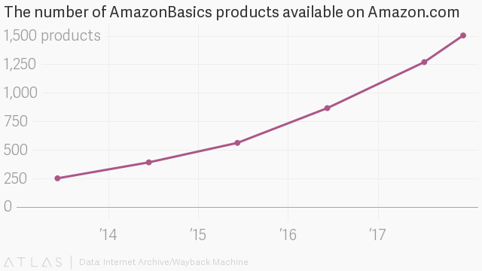
ADMINISTRATIVE LAWS AND REGULATIONS
The U.S. has Federal System Government which regulates sales and relocates securities via Securities and Exchange Commission and business completion matters in the Antitrust Division Department Justice (Nasi, Taber & Van Vliet, 2011). This also includes the Federal Trade Commission. I found that Amazon Company has to represent warranties of some goods. The company has to look for the Company Disclosure Schedule in order to submit to Parent Merger Sub as soon as prior to the execution of the conformity. In this case Amazon Company should adhere to administrative laws and regulations such as:
- Bylaws of the surviving corporation
- Officers of the Surviving Corporation
- Effect on Capital Stock
- The company must have Merger Consideration.
- Cancellation of Dissenting Shares
- Exchange of Share Certificate and Book Entry Shares.
Other administrative laws and regulations include Appointment of Paying Agent, Deposit of Merge Consideration, Termination of Payment Fund, and stolen, lost and damaged share certificates, and Treatment of Stock Based Award and Company options.

References
DePamphilis, D. (2019). Mergers, acquisitions, and other restructuring activities. Academic Press.
Stronza, A. (2009). Commons management and ecotourism: Ethnographic evidence from the Amazon. International Journal of the Commons, 4(1).
Ross, F. H., & Presti, S. S. L. (2018). Appraising Retail Properties in the" Amazon Jungle". Appraisal Journal, 86(4).
Nasi, R., Taber, A., & Van Vliet, N. (2011). Empty forests, empty stomachs? Bushmeat and livelihoods in the Congo and Amazon Basins. International Forestry Review, 13(3), 355-368.
Nguyen, Q. C., Li, D., Meng, H. W., Kath, S., Nsoesie, E., Li, F., & Wen, M. (2016). Building a national neighborhood dataset from geotagged Twitter data for indicators of happiness, diet, and physical activity. JMIR public health and surveillance, 2(2), e158.
Yu, B., Willis, M., Sun, P., & Wang, J. (2013). Crowdsourcing participatory evaluation of medical pictograms using Amazon Mechanical Turk. Journal of medical Internet research, 15(6), e108.

